SAVEETHA SCHOOL OF ENGINEERING
SAVEETHA INSTITUTE OF MEDICAL AND TECHNICAL SCIENCES
COMPUTER SCIENCE AND ENGINEERING PROGRAMME
CSA04 – OPERATING SYSTEMS
Name: DHARANI KARTHICK
Reg no: 192521082

LIST OF PROGRAMS
16. Develop a C program for implementing random access file for processing the employee
details.
/* Random access file: employee details */
#include <stdio.h>
#include <string.h>

#define FILE_NAME "employee.dat"

typedef struct {
int id;
char name[30];
char dept[20];
float salary;
int active; /* 1 = record in use, 0 = empty/deleted */
} Employee;

FILE *fp;

long record_count(void) {
fseek(fp, 0, SEEK_END);
return ftell(fp) / (long)sizeof(Employee);
}

int read_record(int id, Employee *e) {
if (id < 1 || id > record_count()) return 0;
fseek(fp, (long)(id - 1) * (long)sizeof(Employee), SEEK_SET); /* jump directly */
if (fread(e, sizeof(Employee), 1, fp) != 1) return 0;
return e->active;
}

void write_record(int id, const Employee *e) {
fseek(fp, (long)(id - 1) * (long)sizeof(Employee), SEEK_SET);
fwrite(e, sizeof(Employee), 1, fp);
fflush(fp);
}

void print_record(const Employee *e) {
printf("%-6d %-20s %-12s %10.2f\n", e->id, e->name, e->dept, e->salary);
}

int main(void) {
setvbuf(stdout, NULL, _IONBF, 0);

fp = fopen(FILE_NAME, "rb+");
if (fp == NULL) fp = fopen(FILE_NAME, "wb+"); /* create if missing */
if (fp == NULL) { perror("fopen"); return 1; }

int choice, id;
Employee e;

while (1) {
printf("\n===== EMPLOYEE RECORDS (RANDOM ACCESS FILE) =====\n");
printf("1. Add employee\n2. Search by ID\n3. Update salary\n");
printf("4. Delete employee\n5. Display all\n6. Exit\n");
printf("Enter your choice: ");
if (scanf("%d", &choice) != 1) break;

switch (choice) {
case 1: {
printf("Employee ID (1 or more): ");
scanf("%d", &id);
if (id < 1) { printf("Invalid ID.\n"); break; }
if (read_record(id, &e)) 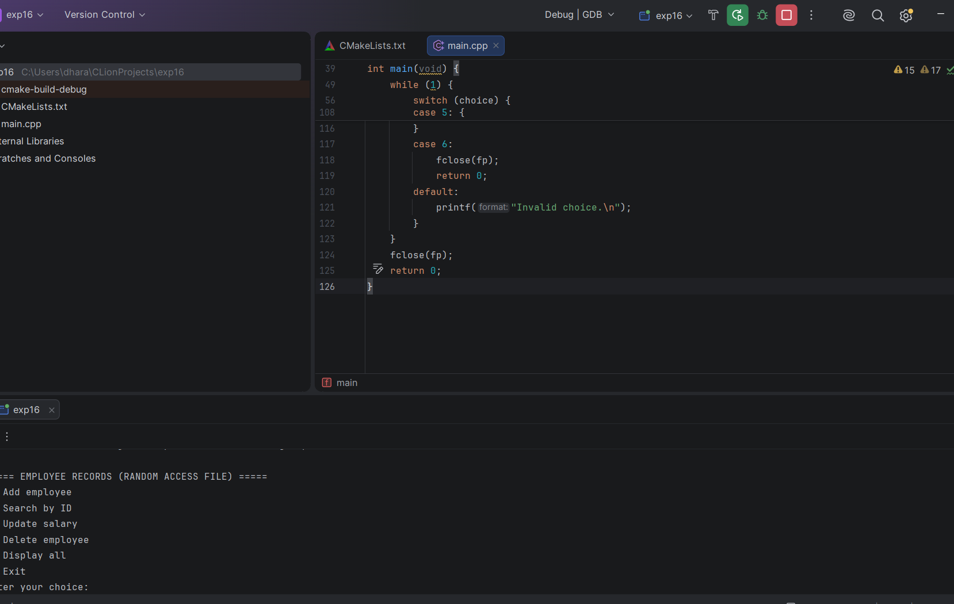

17. Illustrate the deadlock avoidance concept by simulating Banker’s algorithm with C.
/* Deadlock avoidance: Banker's Algorithm */
#include <stdio.h>

#define MAXP 10
#define MAXR 10

int n, m;
int alloc[MAXP][MAXR], maxm[MAXP][MAXR], need[MAXP][MAXR], avail[MAXR];

/* Safety algorithm: returns 1 and fills seq[] if the state is safe */
int is_safe(int seq[]) {
int work[MAXR], finish[MAXP] = {0}, count = 0;
for (int j = 0; j < m; j++) work[j] = avail[j];

while (count < n) {
int found = 0;
for (int i = 0; i < n; i++) {
if (finish[i]) continue;
int ok = 1;
for (int j = 0; j < m; j++)
if (need[i][j] > work[j]) { ok = 0; break; }
if (ok) {
for (int j = 0; j < m; j++) work[j] += alloc[i][j]; /* process finishes, returns resources */
finish[i] = 1;
seq[count++] = i;
found = 1;
}
}
if (!found) return 0; /* nobody can proceed: unsafe */
}
return 1;
}

void print_state(void) {
printf("\nProcess Allocation Max Need\n");
for (int i = 0; i < n; i++) {
printf("P%-8d", i);
for (int j = 0; j < m; j++) printf("%d ", alloc[i][j]);
printf(" ");
for (int j = 0; j < m; j++) printf("%d ", maxm[i][j]);
printf(" ");
for (int j = 0; j < m; j++) printf("%d ", need[i][j]);
printf("\n");
}
printf("Available: ");
for (int j = 0; j < m; j++) printf("%d ", avail[j]);
printf("\n");
}

void print_sequence(const int seq[]) {
printf("Safe sequence: ");
for (int i = 0; i < n; i++) printf("P%d%s", seq[i], i < n - 1 ? " -> " : "\n");
}

int main(void) {
setvbuf(stdout, NULL, _IONBF, 0);

int seq[MAXP];

printf("Enter number of processes: ");
scanf("%d", &n);
printf("Enter number of resource types: ");
scanf("%d", &m);

printf("Enter Allocation matrix (%d x %d):\n", n, m);
for (int i = 0; i < n; i++)
for (int j = 0; j < m; j++) scanf("%d", &alloc[i][j]);

printf("Enter Max matrix (%d x %d):\n", n, m);
for (int i = 0; i < n; i++)
for (int j = 0; j < m; j++) scanf("%d", &maxm[i][j]);

printf("Enter Available resources (%d values):\n", m);
for (int j = 0; j < m; j++) scanf("%d", &avail[j]);

for (int i = 0; i < n; i++)
for (int j = 0; j < m; j++) need[i][j] = maxm[i][j] - alloc[i][j];

print_state();

if (is_safe(seq)) { printf("\nSystem is in a SAFE state.\n"); print_sequence(seq); }
else { printf("\nSystem is in an UNSAFE state (deadlock possible).\n"); return 0; }

char again = 'y';
while (again == 'y' || again == 'Y') {
int p, req[MAXR];
printf("\nEnter process number making a request (0-%d): ", n - 1);
scanf("%d", &p);
if (p < 0 || p >= n) { printf("Invalid process.\n"); continue; }
printf("Enter request (%d values): ", m);
for (int j = 0; j < m; j++) scanf("%d", &req[j]);

int valid = 1;
for (int j = 0; j < m; j++) {
if (req[j] > need[p][j]) {
printf("Error: P%d asked for more than its maximum claim.\n", p);
valid = 0; break;
}
if (req[j] > avail[j]) {
printf("P%d must WAIT: resources not available right now.\n", p);
valid = 0; break;
}
}

if (valid) {
for (int j = 0; j < m; j++) { /* pretend to grant the request */
avail[j] -= req[j];
alloc[p][j] += req[j];
need[p][j] -= req[j];
}
if (is_safe(seq)) {
printf("Request GRANTED. New state is safe.\n");
print_sequence(seq);
} else {
printf("Request DENIED: granting it would lead to an unsafe state.\n");
for (int j = 0; j < m; j++) { /* roll back */
avail[j] += req[j];
alloc[p][j] -= req[j];
need[p][j] += req[j];
}
}
}
printf("Another request? (y/n): ");
scanf(" %c", &again);
}
return 0;
}
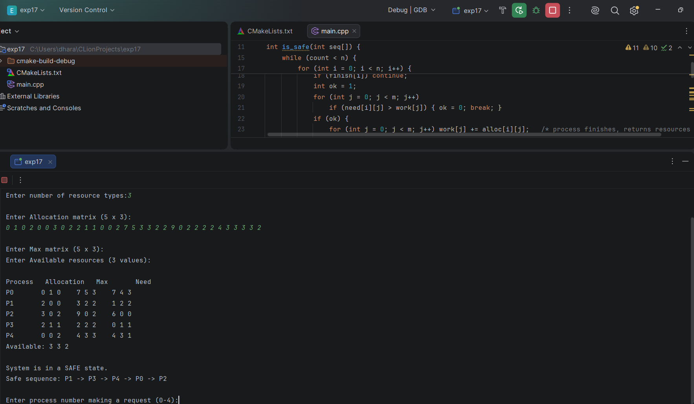
18 Construct a C program to simulate producer-consumer problem using semaphores.
/* Producer-Consumer problem using semaphores (Windows) */
#include <stdio.h>
#include <windows.h>
#define BUFFER_SIZE 5
#define ITEMS_EACH 5 /* items produced/consumed per thread */
int buffer[BUFFER_SIZE];
int in = 0, out = 0;
HANDLE emptySem; /* counts empty slots */
HANDLE fullSem; /* counts filled slots */
HANDLE mutex; /* protects the buffer */
DWORD WINAPI producer(LPVOID param) {
int id = (int)(INT_PTR)param;
for (int i = 1; i <= ITEMS_EACH; i++) {
int item = id * 100 + i;
Sleep(100); /* time to produce */
WaitForSingleObject(emptySem, INFINITE); /* wait for a free slot */
WaitForSingleObject(mutex, INFINITE);
buffer[in] = item; /* critical section */
printf("Producer %d produced item %d at slot %d\n", id, item, in);
in = (in + 1) % BUFFER_SIZE;
ReleaseMutex(mutex);
ReleaseSemaphore(fullSem, 1, NULL); /* one more filled slot */
}
return 0;
}
DWORD WINAPI consumer(LPVOID param) {
int id = (int)(INT_PTR)param;
for (int i = 1; i <= ITEMS_EACH; i++) {
WaitForSingleObject(fullSem, INFINITE); /* wait for an item */
WaitForSingleObject(mutex, INFINITE);
int item = buffer[out]; /* critical section */
printf(" Consumer %d consumed item %d from slot %d\n", id, item, out);
out = (out + 1) % BUFFER_SIZE;
ReleaseMutex(mutex);
ReleaseSemaphore(emptySem, 1, NULL); /* one more free slot */
Sleep(250); /* time to consume (slower than producing) */
}
return 0;
}
int main(void) {
HANDLE threads[4];
emptySem = CreateSemaphore(NULL, BUFFER_SIZE, BUFFER_SIZE, NULL);
fullSem = CreateSemaphore(NULL, 0, BUFFER_SIZE, NULL);
mutex = CreateMutex(NULL, FALSE, NULL);
printf("Producer-Consumer: buffer size %d, 2 producers, 2 consumers, %d items each\n\n",
BUFFER_SIZE, ITEMS_EACH);
threads[0] = CreateThread(NULL, 0, producer, (LPVOID)(INT_PTR)1, 0, NULL);
threads[1] = CreateThread(NULL, 0, producer, (LPVOID)(INT_PTR)2, 0, NULL);
threads[2] = CreateThread(NULL, 0, consumer, (LPVOID)(INT_PTR)1, 0, NULL);
threads[3] = CreateThread(NULL, 0, consumer, (LPVOID)(INT_PTR)2, 0, NULL);
WaitForMultipleObjects(4, threads, TRUE, INFINITE);
for (int i = 0; i < 4; i++) CloseHandle(threads[i]);
CloseHandle(emptySem);
CloseHandle(fullSem);
CloseHandle(mutex);
printf("\nAll items produced and consumed.\n");
return 0;
}

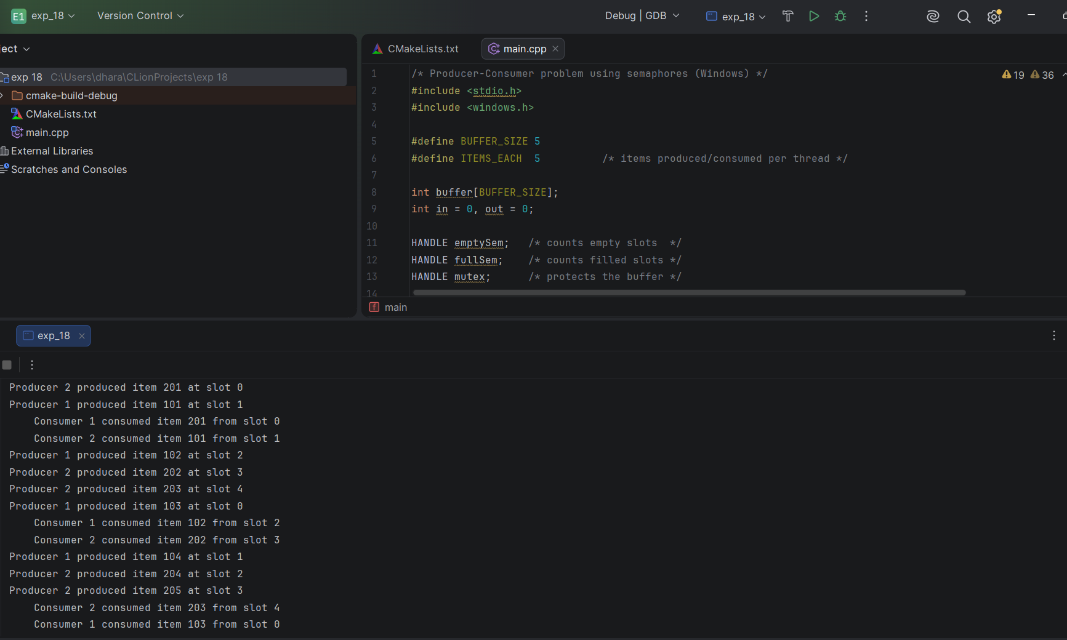
19. Design a C program to implement process synchronization using mutex locks.
/* Process synchronization using mutex locks (Windows) */
#include <stdio.h>
#include <windows.h>

#define LOOPS 500000
#define START_BALANCE 1000

volatile long long balance; /* shared resource */
HANDLE mutex;
int use_lock; /* 0 = no synchronization, 1 = use mutex */

DWORD WINAPI deposit(LPVOID param) {
(void)param;
for (int i = 0; i < LOOPS; i++) {
if (use_lock) WaitForSingleObject(mutex, INFINITE); /* lock */
balance = balance + 1; /* critical section */
if (use_lock) ReleaseMutex(mutex); /* unlock */
}
return 0;
}

DWORD WINAPI withdraw(LPVOID param) {
(void)param;
for (int i = 0; i < LOOPS; i++) {
if (use_lock) WaitForSingleObject(mutex, INFINITE);
balance = balance - 1;
if (use_lock) ReleaseMutex(mutex);
}
return 0;
}

void run_test(int lock) {
HANDLE t[4];
use_lock = lock;
balance = START_BALANCE;

t[0] = CreateThread(NULL, 0, deposit, NULL, 0, NULL);
t[1] = CreateThread(NULL, 0, deposit, NULL, 0, NULL);
t[2] = CreateThread(NULL, 0, withdraw, NULL, 0, NULL);
t[3] = CreateThread(NULL, 0, withdraw, NULL, 0, NULL);

WaitForMultipleObjects(4, t, TRUE, INFINITE);
for (int i = 0; i < 4; i++) CloseHandle(t[i]);

printf("%-22s final balance = %lld %s\n",
lock ? "WITH mutex lock:" : "WITHOUT mutex lock:",
balance,
balance == START_BALANCE ? "(correct)" : "(WRONG - race condition)");
}

int main(void) {
mutex = CreateMutex(NULL, FALSE, NULL);

printf("Start balance: %d\n", START_BALANCE);
printf("2 deposit threads (+1 x %d each), 2 withdraw threads (-1 x %d each)\n", LOOPS, LOOPS);
printf("Expected final balance: %d\n\n", START_BALANCE);

run_test(0);
run_test(1);

CloseHandle(mutex);
return 0;
}